Marijuana Anonymous Convention 2018
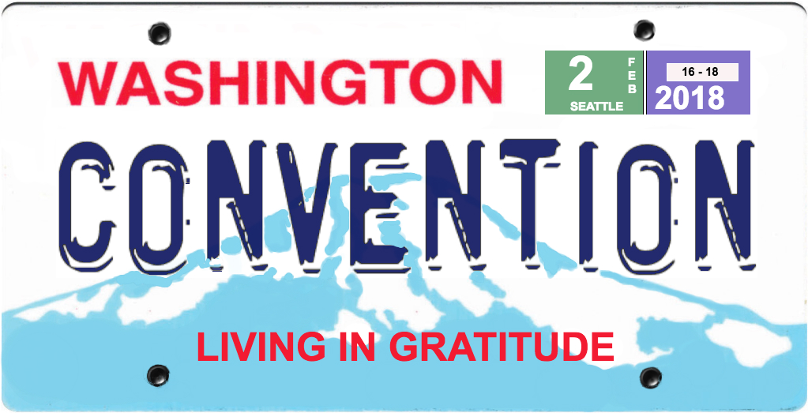
Mail-in Registration Form
(Complete a separate form for each attendee)

February 16 - 18, 2018
Crowne Plaza - Seattle Airport Hotel
Hosted by MA District 4: convention@madistrict4.org

Cost Amount(s) Included

(Spaces expand as you enter text/#s)

Convention Registration $155 early bird (rec’d or
(Includes all meetings, workshops, postmarked by Oct 31, 2017) $
hospitality suite, entertainment,
Friday night snacks, and Saturday $165 general (rec’d or
and Sunday lunches) postmarked Nov 1, 2017 - Jan 24, 2018) $

$175 late (rec’d Jan 25 - Feb 17) $

Banquet (enter text to state your $35 $
preferance for a fish, chicken or
vegetarian meal, and any dietary
restrictions here):
Total Amount Enclosed: $

Your Name:
Address:
City, State, ZIP:
Phone #:
Email:
Are You willing to help at the Convention?:

Please fill-in all applicable information and amounts above and send with your check/money order to: Marijuana Anonymous Convention 2018, PO Box 17452, Seattle, WA 98127. More information and online Convention registration at: mawsconvention.org

Hotel: Crowne Plaza - Seattle Airport, 17338 International Blvd., SeaTac, WA 98188. For discounted room reservations: mawconvention.org or call (844) 733-1389; use booking code MJ1.

