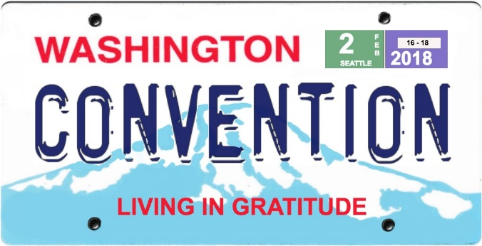
The current "regular registration” rate and the reduced hotel room reservation rates for MA Convention 2018 end on January 24th. The deadline for applying for partial registration scholarships is February 1st.

The Convention is being held February 16 - 18, 2018, at Crowne Plaza Hotel - Seattle Airport, 17338 International Blvd., Seatac, WA 98188. Crowne Plaza has guaranteed special room rates and amenities on a limited block of guestrooms for Convention attendees who book reservations at the hotel by January 24th.

MA Conventions are events where we come together to celebrate our recovery in Marijuana Anonymous and enjoy the fellowship of other recovering marijuana addicts. The theme of the 2018 Convention is “Living in Gratitude”.

The regular registration rate is $165 for the entire weekend. This includes all workshops, recovery and speaker meetings, entertainment, the hospitality suite, snacks Friday night, and lunches on Saturday and Sunday. A Saturday evening banquet is available for an additional $35. Beginning January 25th and continuing until February 16th the “late registration” rate will be $175. Register online at mawsconvention.org.

Partial registration scholarships of $75 - $100 are available. Email convention@madistrict4.org to apply, and for answers to any additional questions.

Thank you, and hope to see you at MA Convention 2018.

MA Convention 2018 Host Committee

